**Professor as a service**

**Team Members:**

**Sahil Mattoo**

**Sumedha Kasarla**

**Kuninti Keerthi Reddy**

1. **Introduction:**

Professor as a service is the digital education model developed to revolve around the professor. Here the professor is responsible for their student’s education. The professor and the students don’t come under any university thereby leaving the professor to make his own choices and putting his talent to use on his own terms. It is a remote model, so it is easy for students from across the world to access it.

1. **Proposed Solution:**

The main idea of this model is to make top notch education easily accessible to all the students, by choosing the professor of their choice. An index will be provided to know the proficiency of the professor. Prices (Tuition fee) for all courses vary depending on the professors. The Subscription fees required for the digital platform will be paid by the respective professor. The design will also include various third parties for getting a degree. The dashboard will include student, professor, course details, list of digital platforms and performance index modules for easy accessibility.

1. **Entity:**

The entities of Professor as a service model are:

1. **Course Directory**: It holds all the courses offered by every professor.
2. **Course**: Each course record will have course ID, course name, maximum credits, faculty ID of the faculty taking the course, number of students enrolled, and the maximum number of seats available.
3. **StudentDirectory**: Each student record has student ID, student name, username and courses they are enrolled in.
4. **ProfessorDirectory**: Each has the record of every professor, their specialized courses, their reputation index and earnings.
5. **Admin**: Admin administrates the transactions between the professor and the various platforms and the transactions between professor and the students.
6. **Degree Directory**: Contains the degree name and the requirements to complete it. Also the list of courses required to attain the degree.
7. **CourseSchedule**: It has details of the name of the course, the start date, end date and the time of the course.
8. **AddPeopleDirectory**: It consists of list of all the users i.e Professors and students.
9. **CourseCatalog:** Consists of list of all the courses and also provides details of newly added courses and last updated details. Different attributes like course number, name, price, description and professors allotted to that course are mentioned in the course class.
10. **CourseSchedule:** CourseSchedule gives details about which course is provided at which timeperiod from the calender class and also provides the revenue of that course.
11. **Calender:** This class defines the exact time period of all the courses available.
12. **Degree:** Provides the details for the degree and the requiremets to attain it.
13. **Seat:** Provides information about the seats which are available for the course.
14. **CourseOffer:** Provides information on the course provided by the professor and links its schedule.
15. **Student:** Represents a single entity of the student directory.
16. **CourseLoad:** The class gives information about all the courses taken by the student.
17. **SeatAssignment:** It provides the mapping of seat with the course load and course offered.

**4.UML DIAGRAM**

**5.SEQUENCE DIAGRAM:**

1. **Professor Sequence Diagram**

1. **Student Sequence Diagram**

1. **Admin Sequence Diagram :**

**6. Architectural diagram :**

**7. GUI REPRESENTATION:**

1. **Application home page:** Graphical user interface, text, application

   Description automatically generated
2. **Login page :Graphical user interface, application

   Description automatically generated**
3. **Sign-up page :Graphical user interface

   Description automatically generated**
4. **Admin Dashboard : A picture containing graphical user interface

   Description automatically generated**
5. **Admin edit Degree details :Graphical user interface, application

   Description automatically generated**
6. **Admin manages all degrees dashboard:Graphical user interface, text, application, email

   Description automatically generated**
7. **Admin view degree details :Table

   Description automatically generated with medium confidence**
8. **Admin creates degree :Graphical user interface

   Description automatically generated with medium confidence**
9. **Professor Dashboard :Graphical user interface, application, email

   Description automatically generated**
10. **Professor create course :Graphical user interface

    Description automatically generated**
11. **Professor edit course :Graphical user interface

    Description automatically generated**
12. **Professor view course :Table

    Description automatically generated**
13. **Student dashboard :Graphical user interface

    Description automatically generated**
14. **Student views all courses :Graphical user interface, text, application

    Description automatically generated**
15. **Student views all degree :Graphical user interface

    Description automatically generated**
16. **Student course details :Graphical user interface, application

    Description automatically generated**
17. **Student views degree details :Graphical user interface, text, application

    Description automatically generated**
18. **Student views earned degree list :Graphical user interface, application

    Description automatically generated**
19. **Student views earned degree details :** 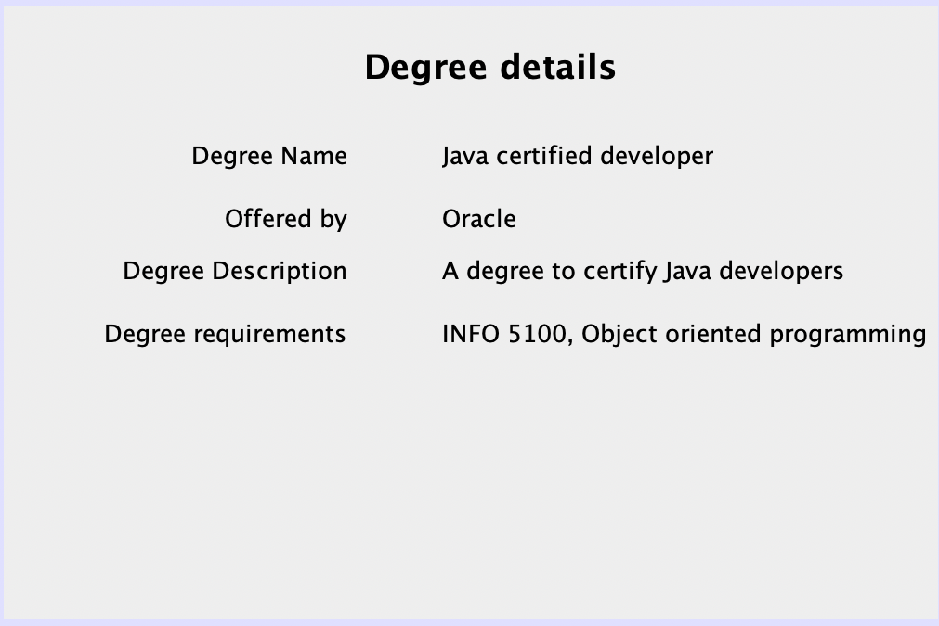
20. **Student views enrolled course details : Graphical user interface, table

    Description automatically generated with medium confidence**

**HOW IS THIS MODEL BETTER?**

Many countries in the world don’t have access to quality education to date. Talented students with will study further and do better in their careers may not be able to afford going to universities abroad or even in their own countries. With internet being accessible to almost everyone these days this digital platform might help a lot more people than before.

Furthermore, in universities students must pay for courses they might not be interested in to attain their degrees, but with this platform students just have to pay only for the courses they want to study making it more affordable.

With the various third-party organizations providing certified degrees to the students, it’s easy to find jobs without officially going to the college. This is how these models will help a lot of people in the future including students from remote locations and the less fortunate.